JAGUAR



Townsville |  | Register



SEPTEMBER 2004

Meeting – 1 SEPTEMBER 2004

Present:
Alan Collins; Kevin Fitz Gerald; Joe Pannia; Dick McInnes; Richard Dixon

Apologies:
Craig Sholz; Michael Fitz gerald

Minutes:
The minutes of the previous meeting held on 4 August 2004, having been previously distributed, were taken as read and were confirmed.

Dick McInnes / Joe Pannia

Business Arising:
Joe Pannia is now the new treasurer. The ‘books’ will be completed by and forwarded to JDCQ as requested (see inwards correspondence).
Reef to Rainforest brochures (see newsletter for further details).

Correspondence:
Inwards:
Townsville Veteran and Vintage & Historic Motor Club Inc. ‘Running Board” July 2004 newsletter
Email request for Townsville registers financial books for 2003/2004 by JDCQ
Reef to Rainforest brochures (see newsletter for further details).

Outwards:
NIL

Alan Collins / Kevin Fitz Gerald

Treasurer’s Report:
Opening of the new Westpac Bank account has been finalised and the existing account held with the university credit union closed.
No bank statements have yet been received from Westpac however Richard reported that the balance at 30 August 2004 stood at $471.40 plus probably the normal interest of a couple of cents for the last couple of months. Outstanding invoices to be paid are for the following items:
$30 for newsletter postage for two issues;
$21 for farewell gift (Tshirt); and
$87 for farewell gift (Model)
The balance after payment of these invoices reduces the balance to $333.40 subject to the accrued interest and any other government fees. Richard will chase the bank for bank statements and a new cheque book.

Richard Dixon / Alan Collins

General Business:
Reminder to remember to notify other related car clubs after Christmas about a possible switch from ‘All British Day’ to All European Day’.

Joe has volunteered to organise this year’s Christmas (yes, Christmas) function for 29 November. Possibilities include garden of Eating (Wayne & Adele’s), the Australian Hotel and Aroi Bangkok on Charters Towers Road. If you have any preference for any one of these or any other restaurant for that matter, please advise otherwise the final choice will be entirely dependant on Joe’s oversensitive taste buds.
Newsletters will cease to be sent to unfinancial members after this month.
Mission Beach Run 25 & 26 September.

Bill’s farewell went off without a hitch at Alan and Margaret’s lovely wine and cheese afternoon recently. There was an excellent turnout with most if not all of the Townsville regulars tasting the various wines and nibblies on offer. Bill was presented with a lovely model of a Mark II for his unswerving loyalty over the last twenty odd years. It would be remiss though, to fail to mention that in losing Bill we have also lost Jean, Bill’s better half. Going back through the club records (before I chuck ‘em out) Jean’s name has popped up for various things including honorary secretary. Obviously Bill and Jean have supported the club tremendously over the past years and their presence at future gatherings will be missed. Three cheers for Bill and Jean!

SEPTEMBER 2004 NEWSLETTER

COVER PHOTO
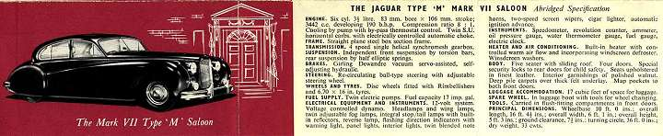
Mark vii
This illustration and others in this month’s newsletter focus on early model Jaguar saloons. Those eagle eyed amongst you will notice the inclusion of some LHD vehicles. They are all courtesy of the World Wide Web.

MISSION BEACH RUN & OVERNIGHT STAY
This is an opportunity too good to miss!

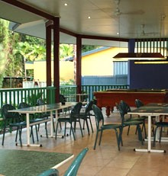
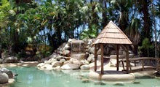
Our overnight run to Mission beach this month is on the weekend of 25 & 26 September where we will be staying at the Mission beach resort, 29 Wongaling Beach Road. The resort management have made the Murray Falls Rooms to suit up to four people available to club members for the princely sum of $80. And without mentioning names Joe, the buffet dinner in the Bistro has a choice of an amazing 82 dishes which should please even those fussiest of eaters. Meals start at $17.95. Breakfast is of course offered and starts from under $10.00. As it is the last Sunday of the month there is an excellent chance of catching the Mission Beach’s famous Sunday Markets from 7:00am.

So far we have four Townsville cars tentatively going however please confirm your attendance and the number of beds you require with Kevin (ph.4778 3144) before 10 September otherwise you may miss out.

Thank you to the Mission Beach Resort management and also to Kaye Hawkins for making this possible

THE FINAL MOVE
Peter Carlson (ret. Townsville now Miva)

Finally got away from Townsville on Wednesday July 28. Had planned to depart about 9:00am but by the time I had jammed every last thing into the E it was 1:30pm. Even managed to squeeze in a few special pot plants and by carefully utilizing every last crevice in the spare wheel well there was just enough room for me to fit in the driver’s seat. Stopped at the rest area on the southern outskirts of Bowen to extricate the Thermos, some Christmas cake and biscuits for a travellers lunch. Had intended to call on Greg Watson at Queens Beach as he had run me at Christmas time when he was searching for an E Type Roadster. However his wife was able to tell me on the phone the night before that he was in Brisbane that week but had bought a Series 2 that he was very pleased with.

Mark vii

Having fed the resident Pee Wees, Blue Faced Honeyeaters and a pair of Rosellas on fruit cake and bikkies, I continued on to Mackay with the E running sweetly. Having played with the carbie settings during my Cairns trip, I felt they were as good as I could get them so had them checked with an exhaust gas analyzer. The assembled mechanics agreed they were spot on, the engine was operating very efficiently and the emissions were very nearly within the limits for a new car fitted with a catalytic converter. Couldn’t get my hat on for three days. Arrived in Mackay just on dark and thought I’d look for a motel with under cover car accommodation. After a couple of laps of the Nebo Rd motel strip I would have settled for anything with an undercover bed. There was not a vacancy to be seen. In desperation I stopped and inquired at a motel where the ‘NO’ part of the vacancy sign was poorly lit, just in case, but the receptionist looked at me strangely and said, “You won’t get a bed at any motel here tonight, don’t you know the mining conference is on this week? We’ve been booked out for 12 months.”

Mark viii

“What about the hotels ?” says I. “They were the first to go.” Says she, “And don’t bother going back to Proserpine or on to Sarina, they’re all booked out too.” I tried a couple of backstreet motels but got the same response. Remembered seeing a sign on the northern outskirts pointing to some units off the highway so went back to investigate. Finished up dodging potholes on a dirt track between cane paddocks before I found it but was informed I was about the 15th person to be turned away that night. Spending the night sitting bolt upright in the driver’s seat of the E was looking like the only option when inspiration struck.


Digging out my trusty address book I looked up Tonny and Lyn Wolzac’s address at Bucasia and decided to throw myself on their mercy. By 7:30 I was knocking on their door. It is in times of desperation like this that you truly appreciate the benefits of belonging to a club with such hospitable people as Tonny and Lyn. I was immediately welcomed and while Tonny found a cover to put over the E, Lyn made up a bed for me. When I mentioned going out to get something to eat my hosts would have none of it saying they had not eaten themselves and I was more than welcome to join them. Pretty soon we were discussing Jaguars from MK Vs to Lyn’s beautiful new baby, a Walkinshaw XJS convertible, over a relaxing glass of wine.

Back on the road next morning I couldn’t help thinking how fortunate I’d been that no motel rooms were available the night before. Stopped for morning tea at a little park in the main street of Marlborough that was full of caravanning Victorians. When my Thermos and bikkies appeared so did a polite Rainbow Lorikeet who sat patiently beside me and waited for me to offer some biscuit. Immediately I did so 20 of his rowdy mates descended on me, perching on my arms and gobbling the biscuit out of my hand as well as helping themselves to the biscuits still in the container. I had just restored order on the biscuit front when I noticed two of them drinking my tea ! On arriving in Rocky I tracked down the address of a friend from my days at MacKenzie River School who has retired to the northern suburbs. Found her house but she wasn’t home so had a chat to a friendly neighbour who promised to tell her I had called. Headed out to the Yeppon Lagoons for lunch with the ducks and waterhens. The tables were taken so I sat on a stump surrounded by curious water birds. One duck sidled up and stood on tiptoe to inspect the sandwiches on my lap. She was quite indignant when I offered her some lettuce and made it clear she expected some bread.
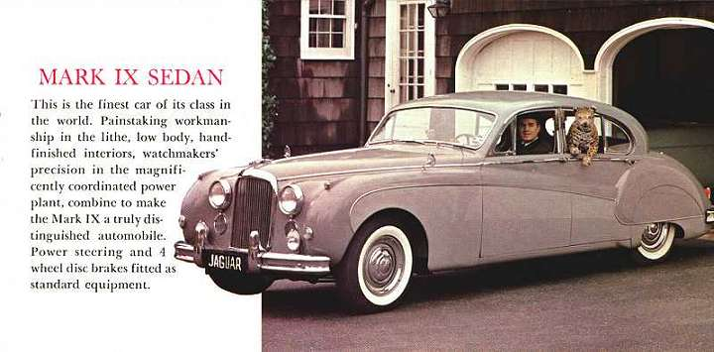

At the Boyne River Roadhouse I decided to try some Caltex Vortex high octane U.L.P. and found the E liked it. Arrived in Gin Gin just on dusk and rang friends at nearby Wallaville. They were coming into Gin Gin with friends for a meal so arranged to meet up with them at the hotel where we enjoyed a very good meal and caught up with info. on all the families in the district where I enjoyed two and a half years of teaching in the early 80s. Spent the night with my Wallaville friends, inspected their cane in the morning (they’re having a good crushing and getting by despite poor prices) then visited some other friends in Wallaville and Bucca before continuing on in the mid afternoon.
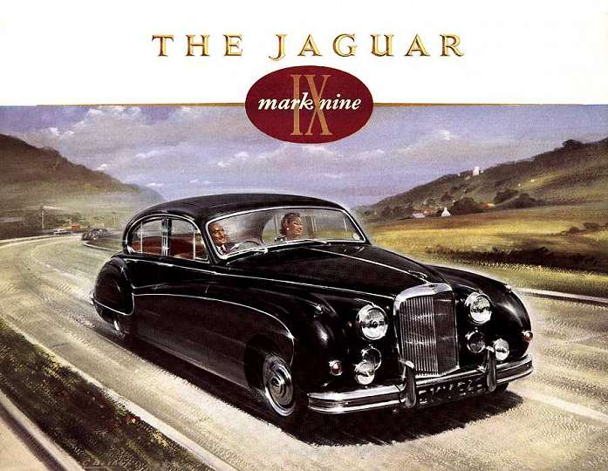
Mark ix
Pulled in at a public phone in Childers to call home in case they wanted anything picked up on the way home. Found out things were in a state of upheaval. Mum had received three phone calls from T.N.T. during the day, to advise that they were delivering my XJ6 and MkV that afternoon (they had advised me in Townsville the cars wouldn’t be delivered until the following week) and wanting to know if their car carrier would fit under the bridge at Miva and if someone would be on hand to help them unload the MkV. Mum didn’t know on either score. She didn’t know whether I’d be home in time and my nephew was taking my brother to hospital in Noosa for an urgent operation. As it happened, John found the car carrier wandering around Gunalda on his return from Noosa and directed him on an alternate route round the bridge and was on hand to help unload the cars. I arrived just as they finished and darkness was falling. The surgeon had just rung my sister in law to tell her my brother had needed a bigger operation than they thought. What was thought to have been appendicitis turned out to be an infection in an offshoot from the bowel necessitating the removal of a bit of the bowel and reconnecting it. They removed his appendix as well. The operation had been performed just in time. He spent four days in intensive care and two weeks in hospital and is now convalescing at home. As a result I have stepped straight into farm work helping my nephew with dipping, weaning, irrigating, baling hay, feeding molasses, fencing etc. Haven’t had a chance to do any unpacking so the double garage is still packed from floor to ceiling with all my junk. Haven’t had time to make contact with any Jag club members down here yet but will do so when the opportunity arises.
Keep on Jaguaring.

Next month: Peter’s ‘Stalked by Jaguars’ article begins!

FOR SALE / WANTED:

Mark x

For Sale: Series 3 XJ6 fuel pump (Bosch) $150 ono Joe ph: 4778 1072
Wanted: More Newsletter Items, Photographs etc.
Remember: If you wish to advertise anything at no cost from your business to your dirty washing please advise anyone on the contact list below to be included in next months newsletter.

MEMBERSHIP RENEWALS

Just a quick reminder to let you know that this newsletter will not be sent to unfinancial members after this issue.

COMING EVENTS

Wed 1 September Meeting, Shelley’s Diner, Norgate Ingham Road, 7:30pm
Sun 12 September Sunday run departing McDonald’s carpark, Stockland, 4:30pm
Sat 25 & Sun 26 September Mission Beach run & overnight stay
Wed 6 October Meeting, Shelley’s Diner, Norgate Ingham Road, 7:30pm

A SIGN OF THE TIMES

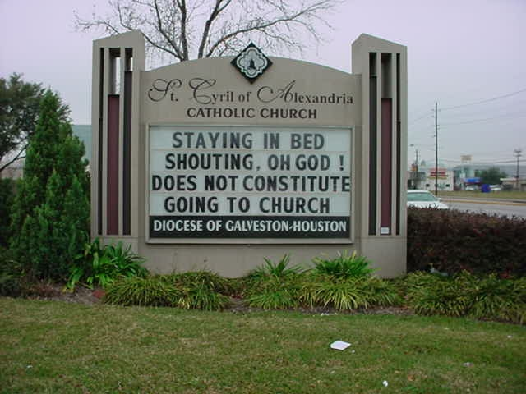

Contact Information:

President Kevin Fitz Gerald 4778 3144
411 Stuart Drive
WULGURU QLD 4811
Secretary Richard Dixon 4789 3672 / 47278803
127 Framara Drive
KELSO QLD 4815
Email: rg.dixon@bigpond.com
Treasurer Joe Pannia 47781072
80 Glenlyon Drive
WULGURU QLD 4811
Email: joepannia@bigpond.com
Social Secretary Craig Scholz 4729 0908
PO Box 518
Townsville QLD 4810

